Problem 1

z

Problem 2

B (30)

Problem 3

n

Problem 4

σ and Sx

Problem 5

\bar{x} (x-bar)

Problem 6

.95 (95 is also acceptable)

Problem 7

n

Problem 8

C (99%)

Problem 9

A (90% -- because it would be wrong 10% of the time)

Problem 10

7.2

Problem 11

8.2393

Problem 12

8.2393 – 7.2 = 1.0393

Problem 13

115

Problem 14

.7652173913 … or about 77%

Problem 15

.84269 – .7652173913 = .0774726087 … or approximately 7.7%

Problem 16

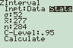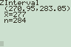

… So 270.95 to 283.05

Problem 17

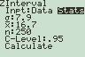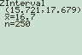

… So 15.721 to 17.679

Problem 18

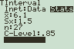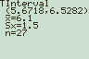

… So 5.6718 to 6.5282

Problem 19

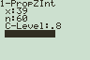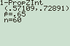

… So .57109 to .72891 or 57% to 73%

Problem 20

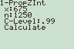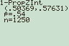

… So .50369 to .57631 or 50% to 58%

Problem 21

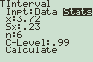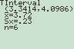

… So 3.3414 to 4.0986

Problem 22

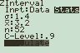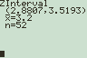

… So 2.8807 to 3.5193

Problem 23

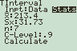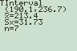

… So $190.10 to $236.70

Problem 24

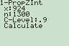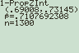

… So .69008 to .73145 or 69% to 73%

Problem 25

.5*.5(1.96/.02)^2 = **2401** (Since it comes out even, you don’t have to round up.)

Problem 26

(1.645*12.5/1.5)^2 = 187.9184028 … round up to **188**

Problem 27

.68*.32(1.44/.05)^2 = 180.486144 … round up to **181**

Problem 28

(1.44*.5/.2)^2 = 12.96 … round up to **13**

Problem 29

Significant means something was unlikely to happen by chance.

Problem 30

A 5% level of significance means there is a 5% chance you will say the result was significant when it really just happened by chance … so a 5% chance you are wrong in saying there is a significant result.

Problem 31

α … alpha

Problem 32

A … .01 (as low as possible, because it’s the probability you’re wrong)

Problem 33

H1 = Sugar-Os have significantly less riboflavin than claimed.

H0 = Sugar-Os don’t have significantly less riboflavin than claimed.

Problem 34

H1 = People who attend sports events earn significantly less than those who go to the theatre,

H0 = People who attend sports events don’t earn significantly less than those who go to the theatre.

Problem 35

< … because the question asks whether they have less riboflavin than claimed

Problem 36

< … because that’s what the question asks and because $87,900 < $127,400

Problem 37

If the p-value is less than the level of significance ( P < α), then your result is significant.

Problem 38

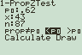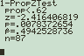

P = .0078372654

Conclusion: Since the p-value is less than the level of significance, **YES** this is significant.

Percentage: This is  given on your calculator … .49425 or about 49.4%

(You could also just divide 43 ÷ 87 to get this answer.)

Problem 39

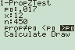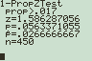

P = .0563371055

Conclusion: Since .0563371055 > .05, **NO** this is not significant.

Problem 40

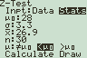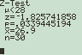

$α$ = .10

P = .0339445194

Conclusion: Since .03 < .10, **YES** this is significant.

Problem 41

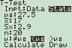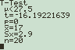

The first screen shot shows how to fill in the variables.

P = 0 (This is **extremely** unusual, but it’s because the dolls are so much smaller than

actual human women.)

Conclusion: Since 0 < 1%, **YES** this is significant.

Problem 42

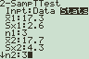 … 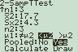 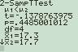

The values of the variables are shown on the input screen above.

P = .4485001012

Conclusion: Since 45% > 5%, **NO** this is NOT significant.

Problem 43

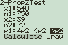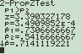

The variables are shown on the input screen above.

P = 3.4909852 X 10-4 or 0.000349852

Conclusion: Since .0003 < .05, **YES** this is significant.

Problem 44



P = .0078372654

Conclusion: Since .0078 < .01, **YES** this is significant.

Problem 45

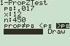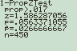

P = ,0563371055

Conclusion: Since 5.6% > 5%, **NO** this is NOT significant.

Problem 46

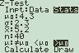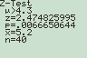

P = .0066650644

Conclusion: since .006665 < 10%, **YES** this is significant.

Problem 47

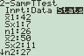 … 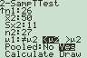 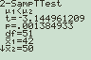

P = .001384933

Conclusion: Since .001 < .01, **YES** this is significant.