NAME: ________________________________
Date:_________________________________

Statistics … Business Statistics
Estimation

Find these confidence intervals. You will most likely use a graphing calculator and write your answer in the form { LB , UB }.

_____________________________1. The U.S. Bureau of Labor Statistics collects information on the ages of people in the labor force. They sample 50 workers and find an average age of 44.7 years. The standard deviation for all workers is 12.1 years. Use this information to find a 99% confidence interval (z-interval) for the mean age μ of all people in the labor force.

____________2. What is the margin of error in problem #1?

_____________________________3. The Fluffy Fun pet toy company sells boxes of catnip. A sample of 40 of their “jumbo” boxes of catnip found that they weighed an average of 16.3 ounces, with a standard deviation of 0.04 ounces. Use this information to find a 95% estimate (z-interval) for the mean weight of the entire population of jumbo boxes of catnip.

_____________________________4. Igor wants to know how many French fries there are in an average serving. He goes to McDonalds and buys 9 orders of medium fries and counts how many fries are in each one. He finds the average is 36 fries, with a standard deviation of 5. Use this information to find a 90% confidence interval (t-interval) for the actual average number of fries in a medium order at McDonalds.

____________5. What is the margin of error in problem #4?

_____________________________6. A sample of 8 cups of coffee finds that the average temperature of the coffee is 152º with a standard deviation of 10º. Find an estimate (t-interval) for the actual average temperature of coffee, with 95% confidence.

_____________________________7. In surveying how many licks it took to get to the center of a Tootsie-Pop®, a group in Statistics class found that 18 out of 30 people bit the sucker before they got to the center. Use this information to find a 90% interval estimate (1-proportion z-interval) of the actual percentage of people who would bite a Tootsie-Pop® before they reach the center.

_____________________________9. The Indiana Department of Education surveyed 350 high school boys in that state and asked them if they participated in any illegal activities in the past week. 182 of the boys admitted that they had participated in at least one illegal activity in the past week. Use this information to find a 99% confidence interval (1-proportion z-interval) for the actual percentage of high school boys in Indiana who have participated in illegal activities in the past week.

____________9. What is the margin of error in problem #4?

In this class we have discussed z-intervals and t-intervals as ways to estimate averages. Answer these questions:

____________10. Which statistic (z or t) is most often used when a large sample is available?

____________11. How large does a sample have to be to be considered a “large” sample in statistics?
A. 10 B. 30 C. 100 D. 300 E. 1000

The TI-83 input screens for interval estimation look like the screen illustrations below:
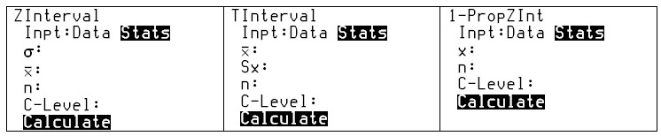
On these input screens …

____________12. Which variable stands for the total number in a sample?

____________ and ____________13. Which two variables stand for standard deviation?

____________14. Which variable stands for the mean (average) of the sample?

____________15. In a 1-proportion z-test, which is larger, “x” or “n”?

The results from a TI-83 interval estimate screen are shown below:
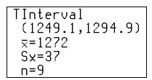
Use this information to answer the questions below.

____________16. What is the margin of error in the t-interval problem shown above?

