Example
LOS ANGELES TIMES – February 4, 2005

IQ as a Matter of Life, Death

- Anderson Hawthorne has been convicted of murdering a rival gang member in Los Angeles.
- He has been sentenced to death.
- His lawyer is appealing the sentence, saying that Hawthorne is mentally retarded.
- It is illegal to execute the mentally retarded in the United States.

QUESTION …
Is he retarded?
- The defendant’s IQ has been measured at 71.
- The state used to define 80 or less as “mentally retarded”.
- Due to the stigma attached to that label, they recently changed the definition to 70 or lower.
- For IQ, the average is 100, and the standard deviation is 15.

Consider
- What percent of all people have an IQ less than 80?
- … less than 70?
- … less than 71?

Problem
You are a college admissions counselor, considering two students for admission. Jolene got a score of 25 on the ACT, while Roger got a score of 1600 on the new version of the SAT. Who did better on their college placement test?

To answer both of these questions, we will use standard scores (or z-scores)

Z-Scores (or standard scores)
- Tell how many standard deviations a score is away from the mean.
or

A z-score of 0 is average

Positive z-scores are above average

Negative z-scores are below average

Empirical Rule

In any distribution that is approximately normal:

- 68% of the data is within 1 S.D. either side of the mean
- 95% of the data is within 2 S.D.s either side of the mean
- 99.7% of the data is within 3 S.D.s either side of the mean

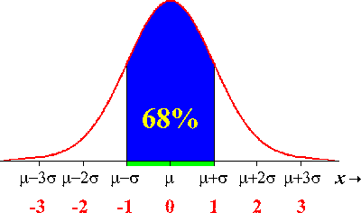

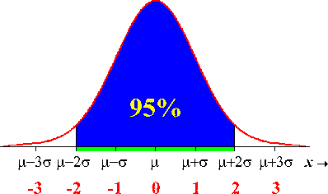

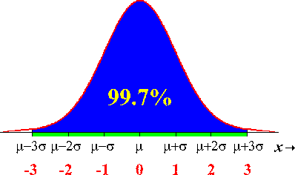

So, … using the empirical rule:

- 68% is between z = -1 and z = 1
- 95% is between z = -2 and z = 2
- 99.7% is between z = -3 and z = 3

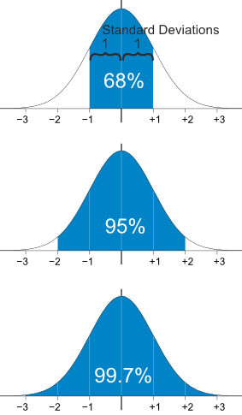

Problem
What percent of the population has an IQ above 120?

Area under normal curve
=
Probability of achieving various scores

What we need to do is find the area under the normal curve in the tail beyond an IQ or 120.
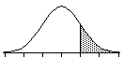
120

Theory: Calculus (antiderivative) gives area under normal curve between two points.

Good news: Somebody’s already done it for you.
- The results are given as tables in your book.
Useful things to know:

- The whole normal curve has an area of 1 (or 100% of the data)
- Each half of the normal curve has an area of .5 (or 50% of the data)

Your book has two tables –
- the “TAIL” table 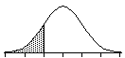

- the “BIG” table 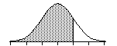

To decide which table to use, it doesn’t matter whether z is positive or negative.
What matters is whether you have a big area or a small area.

TYPES OF PROBLEMS

“Tail” Problems
- z > POSITIVE
- z < NEGATIVE
- Just look up in “tail” table.

  - Example: z > 1.72

  - Example: z < -2.33

“Big” (over half) Problems
- z > NEGATIVE 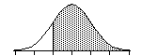
- z < POSITIVE
- Just look up in “big” table.

  - Example: z > -1.23

  - Example: z < 2.07

“Same Side” Problems
- positive < z < positive 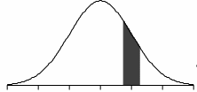(between two positive numbers)
- negative < z < negative 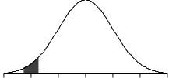(between two negative numbers)

- Look up both numbers in the same table.
- Subtract (BIG – SMALL) to get answer.

  - Ex.: 0.45 < z < 1.93

  - Ex.: -2.44 < z < -1.60

  - Ex.: 0 < z < 1.54

“Both Sides” Problems
- negative < z < positive 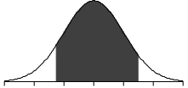(between a negative and a positive)
- Look up both numbers in “tail” table.
- Subtract both tails from 1 … 1 – FIRST – SECOND
  - Ex.: -1.28 < z < 0.55

Back to the original problem…

What we need to do is find the area under the normal curve in the tail beyond an IQ or 120.
120
FIRST, find the z-score associated with a an IQ of 120. (To do this, you need to know that for IQ =120 and s=15.)
… So

NOW, find the percent of scores that are greater than 1.33 (look up in “tail” table).

- .0918 … so about 9%.

1.33

Sometimes problems are presented backwards.

Find “z” so that 70% of all scores are less than “z”.
70%

Look through the columns in the “big” table for the number closest to .7000 .
- The two closest are .6985 and .7019 .
- .6985 is the closest.
- The associated z-score is 0.52, which is the answer.

Back to the IQ Example
- For IQ, the average is 100, and the standard deviation is 15.

IQ of 70
z = (70-100)/15 = -2.00
IQ of 80
z = (80-100)/15 = -1.33
IQ of 71
z = (71-100)/15 = -1.93

We want the probability z is LESS than each of these numbers.
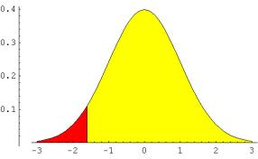

They are all TAIL problems.

IQ or 70
P(z < -2.00) = .0228
IQ of 80
P(z < -1.33) = .0918
IQ of 71
P(z < -1.93) = .0268

Back to the ACT/SAT Example
For ACT …
Mean = 19.2
S.D. = 5.7
For new SAT …
Mean = 1511
S.D. = 290

JOLENE (25 ACT)
z = (25 – 19.2)/5.7 = 1.02
ROGER (1600 SAT)
z = (1600 – 1511)/290 = 0.31

Jolene’s z-score is higher, so she did better.

